

Dr. Jillian, Moran inc.

2016-12-23

Dr. Moran

87901 Amy Bypass Apt. 739, Port Lauraton, TX 21901

Phone: 6207540844

Fax: 6214508894

**Re:** Ashley, Roberts

**PHN:** 4638438263

**Birthdate:** 19-Dec-1975

**Address:** 499 Davis Field, New Erik, PR 71402

**Patient number:** 5551204839

To Whom It May Concern:

This is a medical letter to state the above patient is pregnant with expected delivery date of 26-Jul-2025. Hoping this information is satisfactory for your requirements.

Thank you.

Sincerely,

Dr. Jillian, Moran

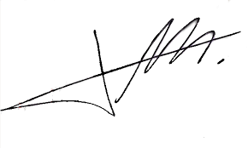

FRCS© NCMP

Clinical Assistant Professor, UBC

Department of Obstetrics and Gynecology SMH